SFTP Monitoring Tool

SFTP Monitoring is a key feature to minimize business impact that is originated by malfunction of the SFTP Adapters. This document explores two options to have this feature available.

- Option 1: Setup BizTalk 360 to use the built-in feature
- Option 2: Implement the SFTP Monitoring Tool from scratch

Option 1: Setup BizTalk 360 to use the built-in feature

BizTalk 360 has already created a whole infrastructure to support different monitoring features, including monitor SFTP Folders. The advantage is that Smile Doctors can start acquiring a license for this feature only, and then enabling more monitoring tools as needed.
Here some details about this feature:
- The feature is called “Folder Monitoring > SFTP”.
- The license price can be asked here: https://www.biztalk360.com/pricing/
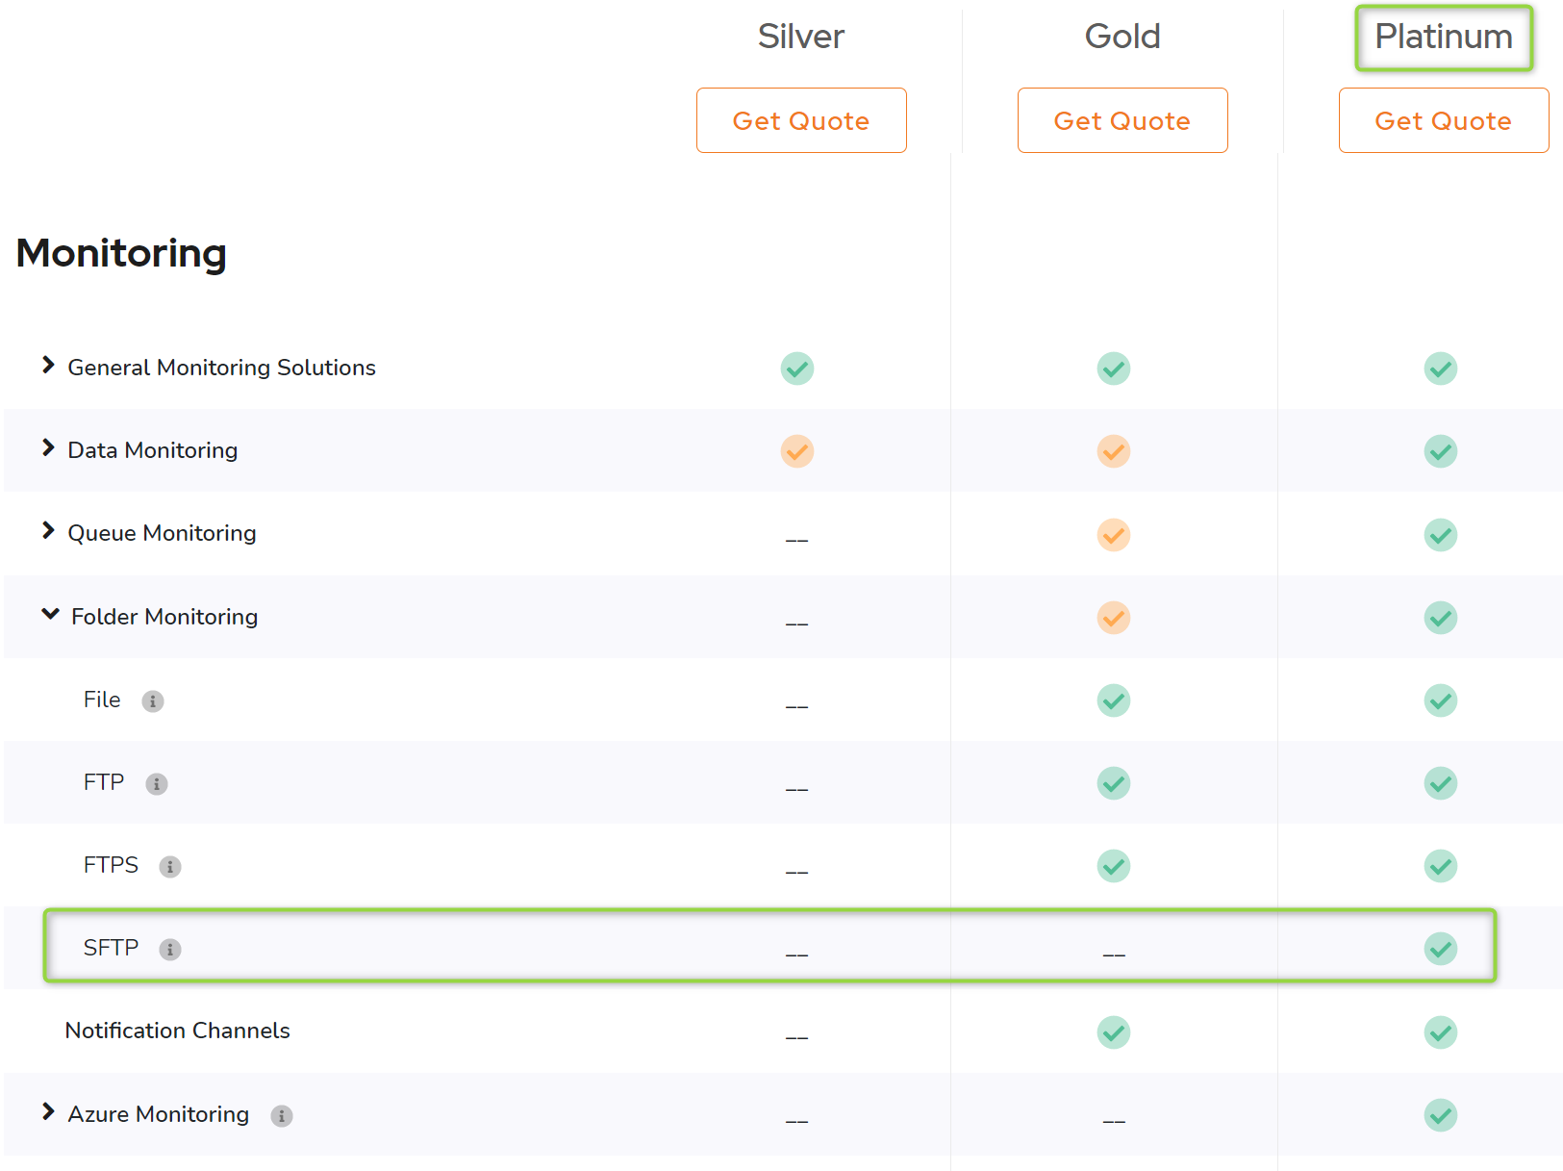
Other resources
[1] Blog: SFTP Monitoring
https://www.biztalk360.com/blog/why-did-we-build-ftp-sftp-monitoring-for-biztalk-server/

Option 2: Implement the SFTP Monitoring Tool

The advantage of implementing the SFTP Monitoring Tool from scratch is that it can be customized as needed. On the other side, the disadvantages are the costs associated to the development + maintenance, the time needed to have the application implemented, and finally a small probability to have the service down.

To clarify the effort needed for this application, below the key features
- It will be a windows service application
- It will support email capabilities to notify watchers
- It will generate an MSI Installer
- It will check periodically for not consumed files in the SFTP folders

Conclusions

It is important to adopt one of the options, or even a third option if any. Because what is important here is to start monitoring the SFTP folder to minimize the impact for the business in the future.

